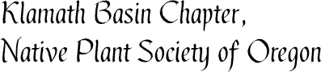
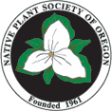

November 6, 2017 Meeting Notes:

Treasurer’s Report
The required $50 dollar fee was sent to the Secretary of State. Current balance is $97.26. Dan has $8.75 (membership dues from state NPSO) to deposit.

Membership Renewals
Memberships expire at the end of the calendar year and are managed by the state NPSO. Sending in dues now will mean our chapter gets our portion of the money back the first quarter of 2018. People can join/renew on line with a credit card, or print out the form and send in a check.

Growing Native Plants Conference
Todd has been in contact with Linda Hardison of the Oregon Flora Project regarding a potential native plant conference this spring. Linda estimated the cost would be around $1900 to get the same three speakers that presented at the Bend conference last spring. Bend attendees were charged $40. The group decided that we would not be able to raise that kind of money by this spring, and charging more than a few dollars would significantly limit attendance in Klamath Falls. Todd had initially proposed applying for a $500 cultural grant, but decided not to because it requires a match, and the conference would not really fit the purpose of the grant program.

Linda also sent the agenda for the Bend Conference (attached). Many of the Bend agenda items were also on the list of topics our chapter came up with at the last meeting. The group discussed doing our own shortened program on growing native plants next spring, using local speakers/resources. Multiple ideas were floated around, but no firm decisions were made. Dan suggested forming a committee to work on it. The first meeting will be December 4 at 6:30.

Native Plant Sale(s)
If our chapter does put together a program on growing native plants, we will still plan to do a plant sale at the end of it. Additional sales may take place later in the year. Steve mentioned that proceeds from the first sale could be used to purchase more plants for the second sale.

Sarah Malaby
Secretary

